Components of EDI

1. Application service
2. Translation service
3. Communication service
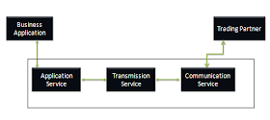

1. Application Services :-
It provides the link between application and EDI. It allows you to send documents from an EDI system. The set of callable routine is used to transfer document from the business application into EDI document, destination can be either intra-company or to the external companies.

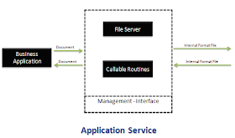

2. Translation service:-
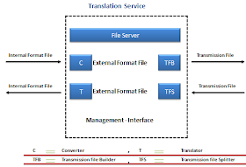
Converts the outgoing documents from an internal format file to an agreed external format. Translates internal document from external format to EDI internal format fil

3. Communication service:-
The communication service sends and receives transmission files to and from the trading partners either directly or by using party service called a valued added network (VAN).

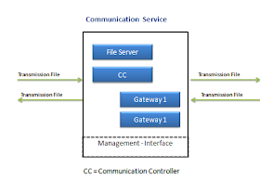

File Types

EDI creates following files as a document passes through the system:
1. Internal format file (IFF):-
It contains single document for single trading partner.
2. External format file (EFF):-
It contains same data as the internal format file translated into the appropriate standard document format.
3. Transmission file:-
It contains one or more document for the same trading partner. Documents of same format are packed into functional groups. The functional groups going to one trading partner are packaged into an interchanged set.

EDI software

1. Translators:-
Every EDI sender and receiver should have EDI translator. It varies based on the computer on which it is going to reside. The computer may be a micro computer or a midrange or a mainframe. Translator reads the fixed length file and generates valid EDI standard and maintains control information.

2. Application link software:-
Application link software is used to collect information from the business application and then it formats into fixed length computer file and passes it onto translators.

